Enter a PER 3 Termination
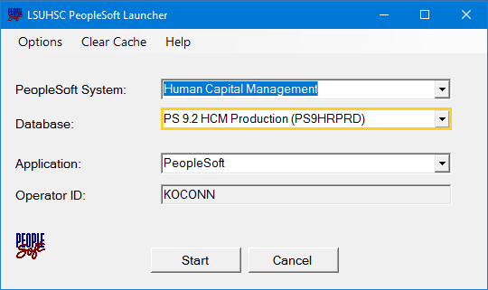
- All tasks for PER 3 - Terminations will be performed in PS HCM Production database.

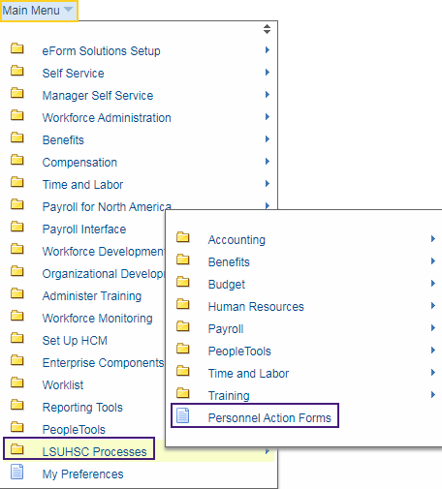
- Click the Main Menu link.

Click LSUHSC Processes, then Personnel Action Forms.

- You can search for an employee by entering his/her first
name or Empl ID.
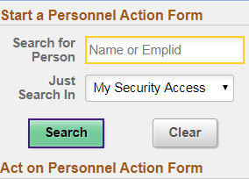
Enter the desired information into the Search for Person field. Enter a valid value e.g. "Darlene".

Click the Search button.

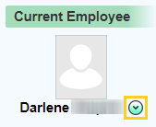
- A list of employees with the first name 'Darlene' displays on the right side of the page Scroll down the page until you locate the correct employee. Click the drop-down button next to the employee name to view available actions.

Click the button to the right of the Employee Name field.

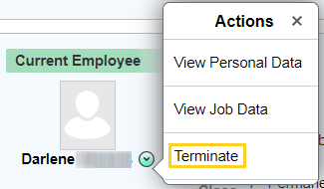
- Click the Terminate button.

- The notes in red explain how to determine the correct effective date, and for the resignation letter or other documentation to be uploaded as appropriate.

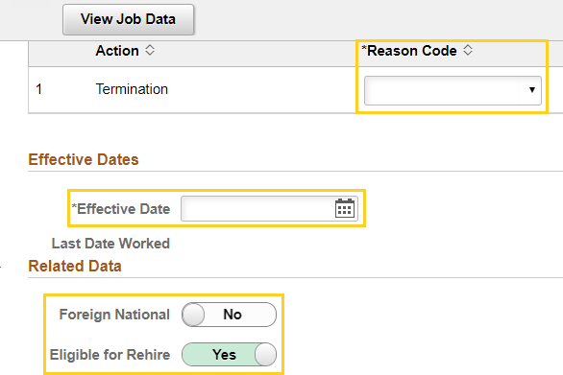
- Once Terminate is selected, a panel will display where you will enter information required for the PeopleSoft termination process.
The Initiator will enter information into the following fields:

Action Termination Reason Code
    - Effective Date
    - Foreign National (Yes or No)
    - Eligible for Rehire (Yes or No)

- Click the button to the right of the
Reason Code field.

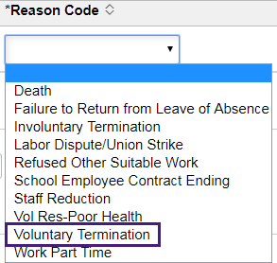
- Click the Voluntary Termination list item.

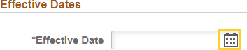
- Click the Calendar button.

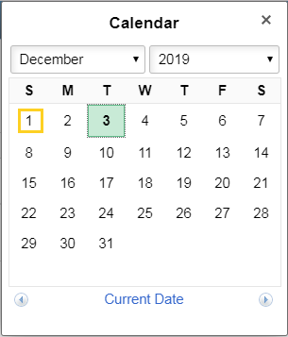
- Click the desired date.

- Click the Submit button.

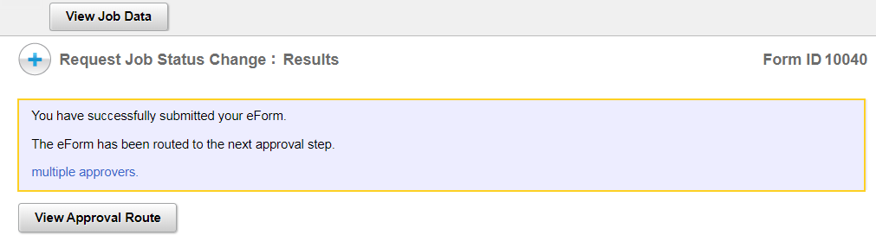
- The Initiator will receive a confirmation message after clicking the Submit button.

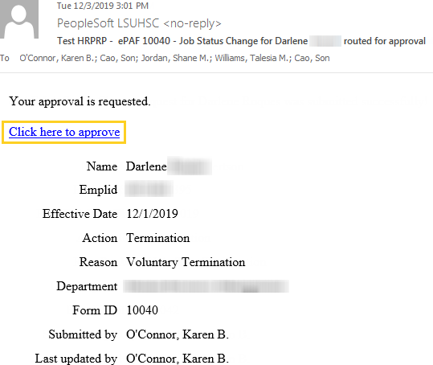
- The next level Approver will receive an email request to approve the transaction. The Approver will click the link in the email notification to navigate to the approval panel.

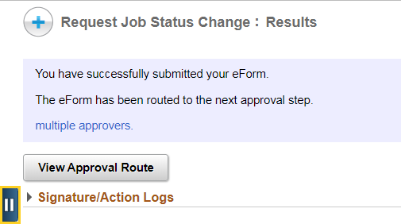
- The Request Job Status Change: Results
confirmation message displays.
Click the Open Sidebar Menu button.

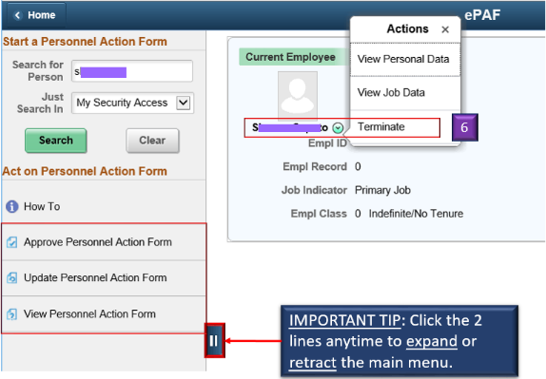
- You have three actions from which to choose on the sidebar menu:

Approve Personnel Action Form
- Update Personnel Action Form
- View Personnel Action Form

- Approvers have two options for navigating to approve a Termination:

Use the email link from the Job Status Change email, or
- Approve Personnel Action Form

- The Update Personnel Action Form option is where the forms go for which the Approver clicked Recycle (with or without comments).

Recycled forms can be modified and sent back to the Approver.

- Click the Approve Personnel Action Form button.

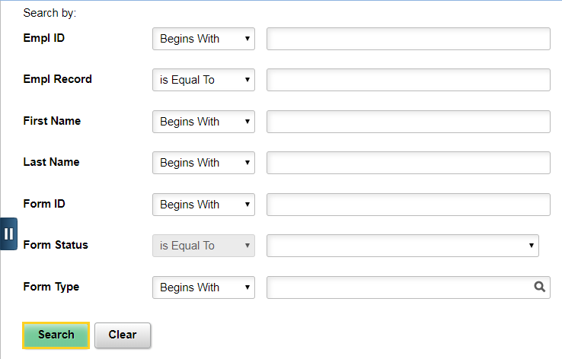
- The Approver can search by any of the various methods displayed, but can also simply click the Search button to either go directly to the next panel, or to get a list of Search result options at the bottom of the page.

Click the Search button.

- Click the Pending - Darlene link.

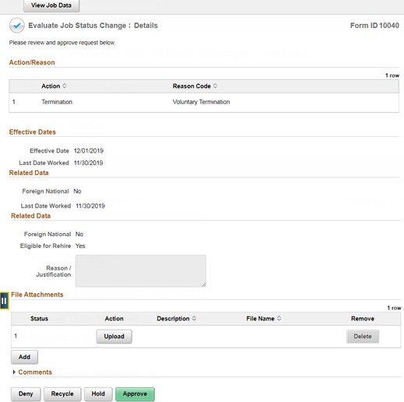
- The Evaluate Job Status Change: Details panel displays.

Click the Open Sidebar Menu button.

- The same basic process is used when selecting the Update Personnel Action Form as choosing Approve Personnel Action Form. However, the Initiator is able to make updates to the form until the form is fully approved.

Click the Update Personnel Action Form button.

- Click the Search button.

- Click the Pending - Darlene link.

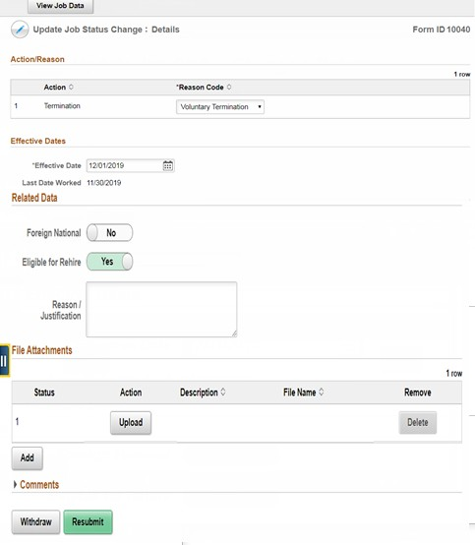
- The Update Job Status Change: Details panel displays.
Click the Open Sidebar Menu button.

- The same basic process is used when selecting the View Personnel Action Form as choosing Approve Personnel Action Form. However, this is a record keeping panel.

Clicking the Search button brings up a history of all transactions the Initiator processed.
Click the View Personnel Action Form button.

- Click the Search button.

- Click the Pending - Darlene link.
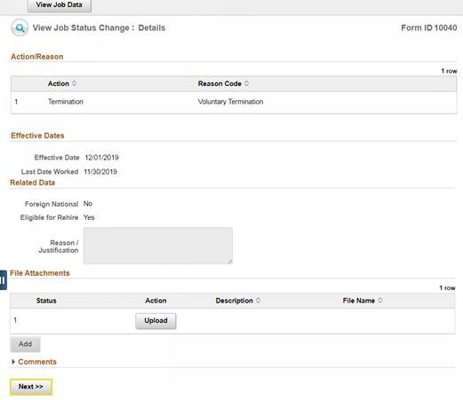
- The View Job Status Change: Details panel displays.
Click the Next button.

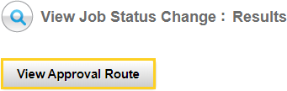
- Clicking the View Approval Route will display the next step Approvers in the termination process.

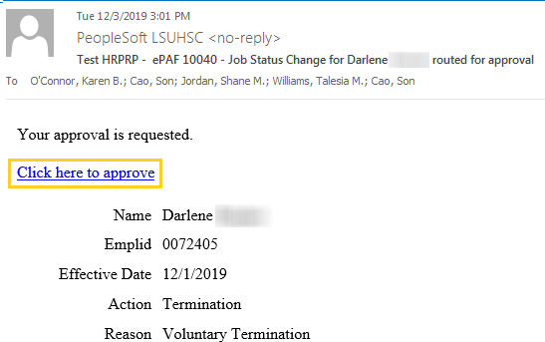
- Clicking the link provided in the Job Status Change email brings the Approver to a panel where s/he is able to view the information entered for the transaction and then approve.

Click the ‘Click here to approve’ link.

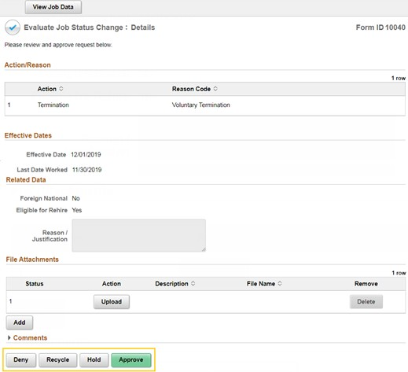
- The Evaluate Job Status Change: Details panel displays.

- The Approver has four options from which to choose:

Approve
  - Hold
  - Recycle
  - Deny

The Approve option will be demonstrated and each of the other options discussed.

- Click the Approve button.

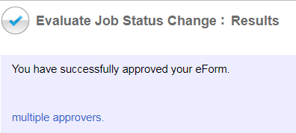
- A confirmation message will display after the Approve button is clicked.

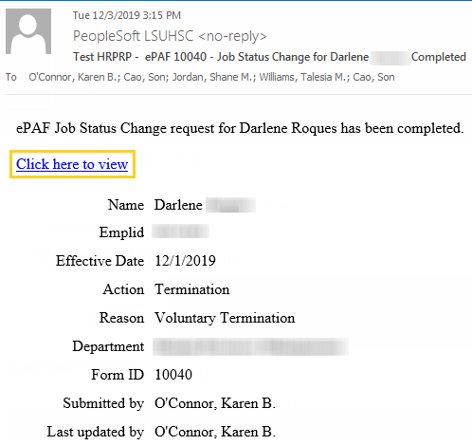
- The Approver will receive a Job Status Change email confirming the Termination has been approved. Select the ‘Click here to view’ link to navigate to the View Job Status Change: Details panel.

- Clicking 'Recycle' will send the form back to the Initiator. The Approver has the ability to add comments relative to what information has to be modified. Typically, this is done when date changes have to made, because the Approver is not able to make changes to the information submitted by the Initiator.

- Clicking 'Deny' will cancel the transaction, which cannot be undone by the Initiator. This would not be done if modifications have to be made, but rather when the employee, or his/her manager, has decided not to move forward with the termination.

- Clicking 'Hold' is similar to clicking Save, where the form still exists, and the Initiator can make modifications, but the termination is not going to occur at that time for various reasons.

- Shown are the 3 different emails (outside of Approve) the Initiator will receive depending on if the Approver chose to Recycle, Deny, or Hold the transaction.

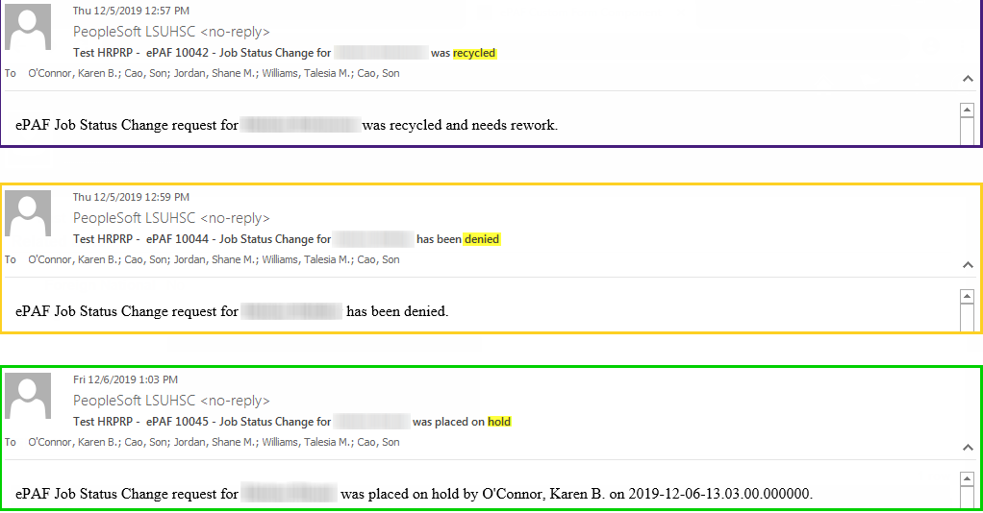

Items to Note
- The Effective Date cannot be before an effective dated row. If an employee’s termination is processed on 10/1, but backdated to 9/1, then the transaction will be allowed as long as the previous effected dated row is not 8/31 or after. So, if an employee has an effective dated row of 9/15, with any type of change (pay rate, transfer, title change, etc.), then the termination transaction would not be backdated prior to 9/16.

- The error shown below will display upon clicking ‘Submit’. The Initiator then has to look at the last effective dated row in PeopleSoft and contact HR Operations to have the change made.
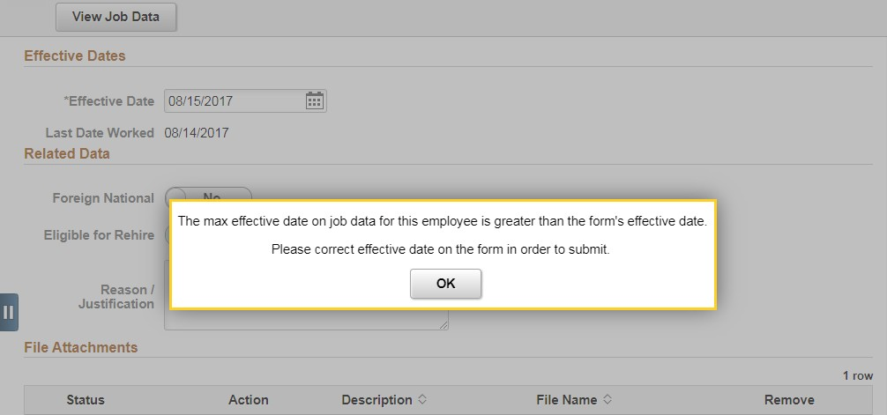

- Once the Approver clicks ‘Submit’, the transaction is sent to HR Operations for final submission. No changes can be made to the form once it is fully approved.

- The Initiator can verify the transaction in Job Data.

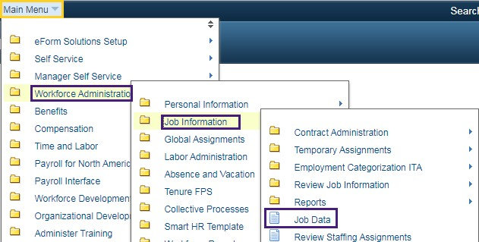
Click the Main Menu link.

Click the Workforce
Administration link.

Click the Job Information link.

Click the Job Data link.

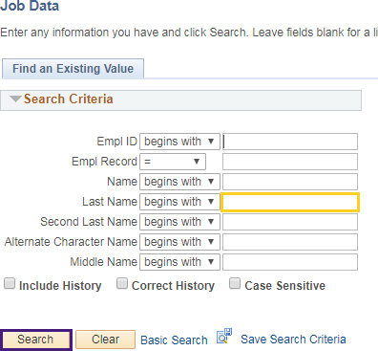
- Enter the desired information into the Last Name field. Enter a valid value e.g. "Darlene". Click the Search object.

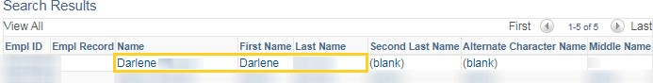
- Click the Darlene link.

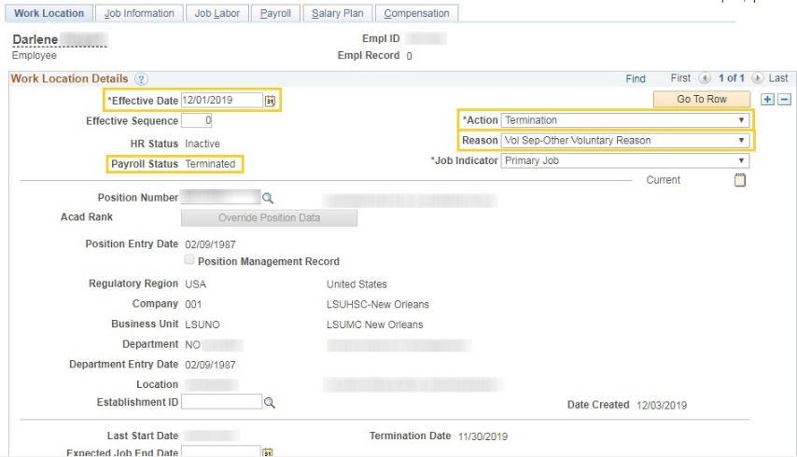
- The employee Job Data record is updated once HR Operations submits the transaction. (HR Operations controls the final submission because transactions cannot be submitted while payroll is processing.

- This completes Enter PER 3 Terminations.

End of Procedure.

