How To Print Your TMS Certificate

Go To **My Learning**:

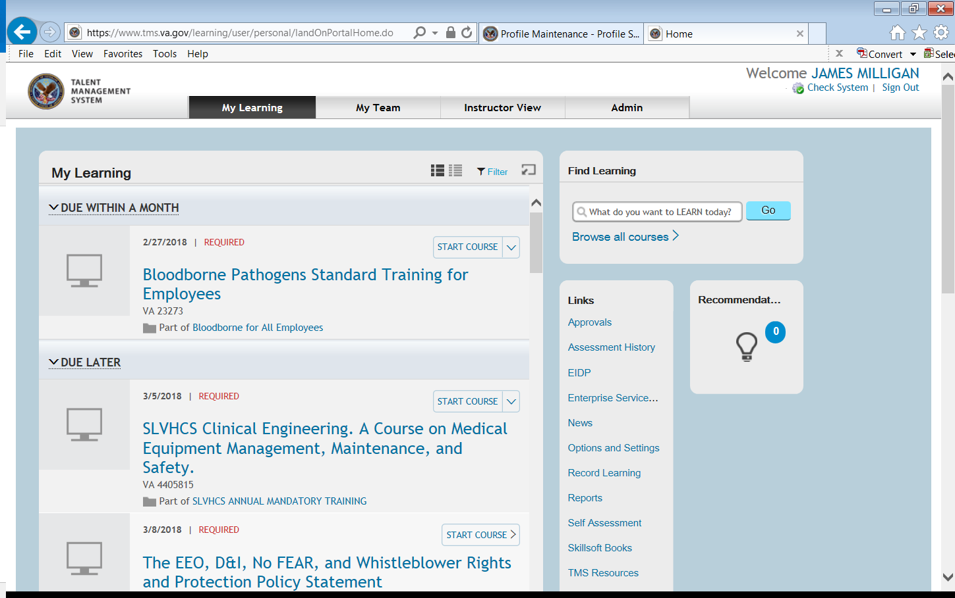

Scroll down to **My History**: Click on it

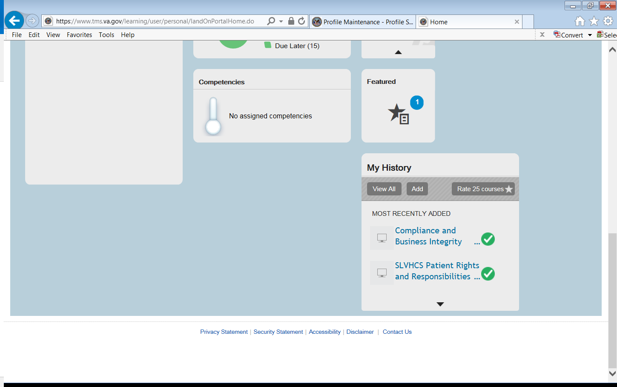

Put your pointer over the training: Click Print Certificate

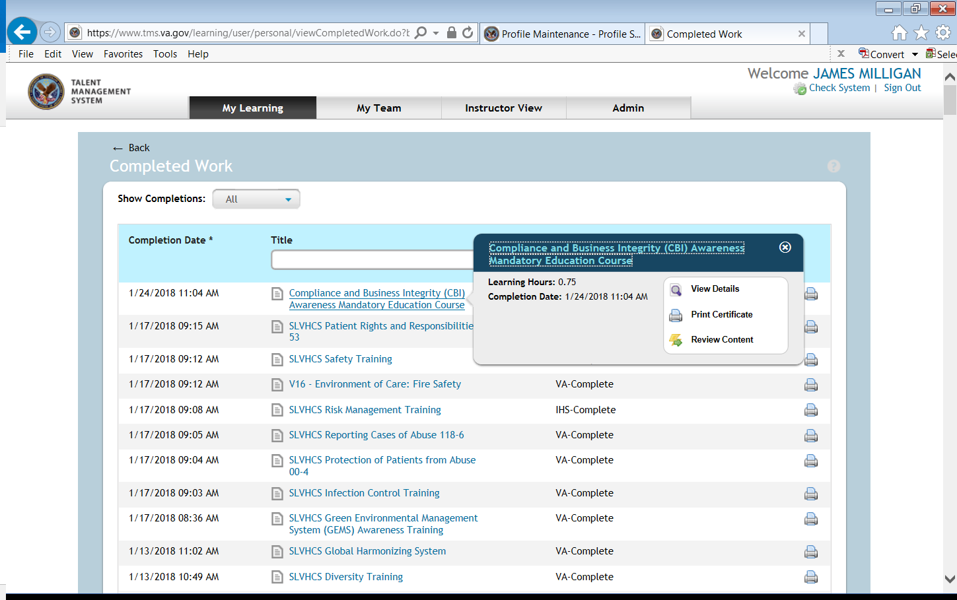

**Print Certificate**

