VA Mandatory Refresher Training – Returning Residents
Log in to https://www.tms.va.gov/SecureAuth35/
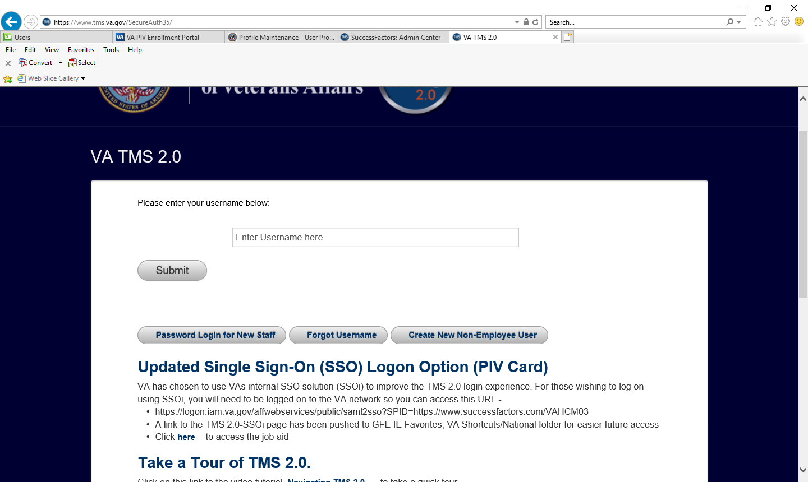
Enter email address (username) and click Submit

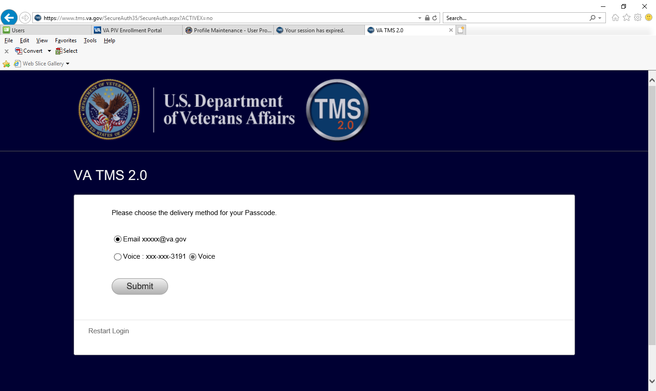
Please choose delivery method for your Passcode
Enter the code and log in
Once logged in – Complete Refresher Training
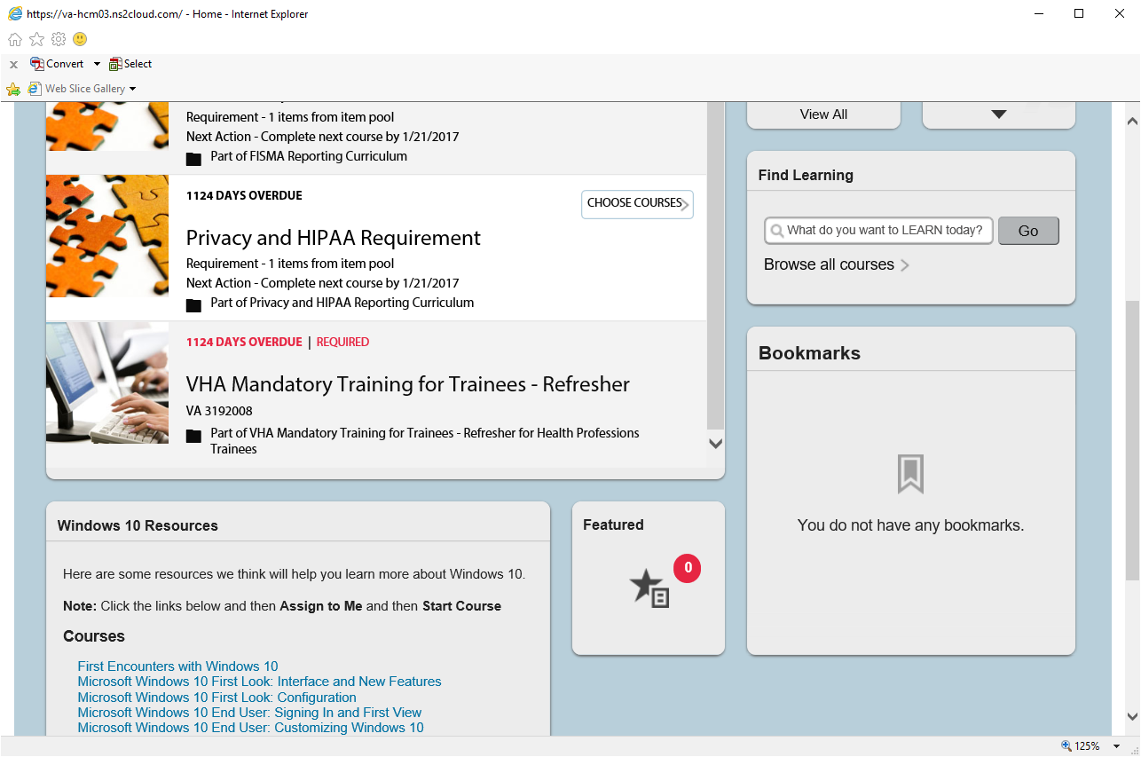
Here is another way to find your training – see instructions below.
Click on My Learning
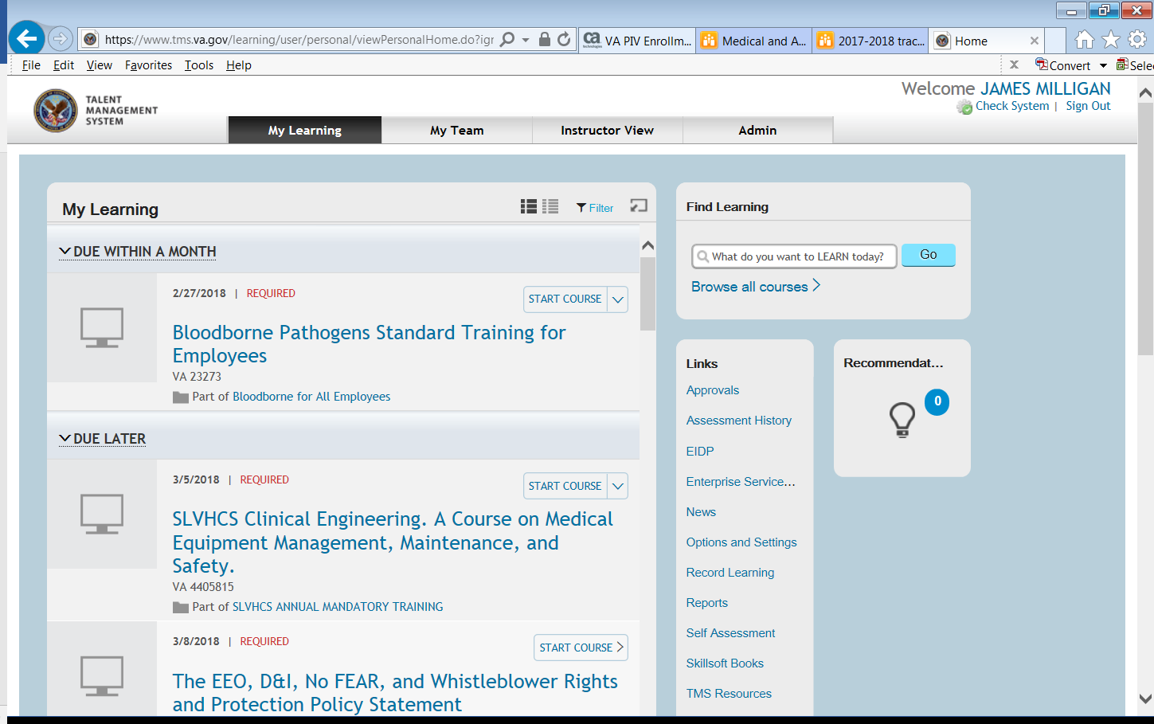
Find Learning – Type 3192008 – press Go (if you need HIPPA - type 10203)

Place pointer over the training course
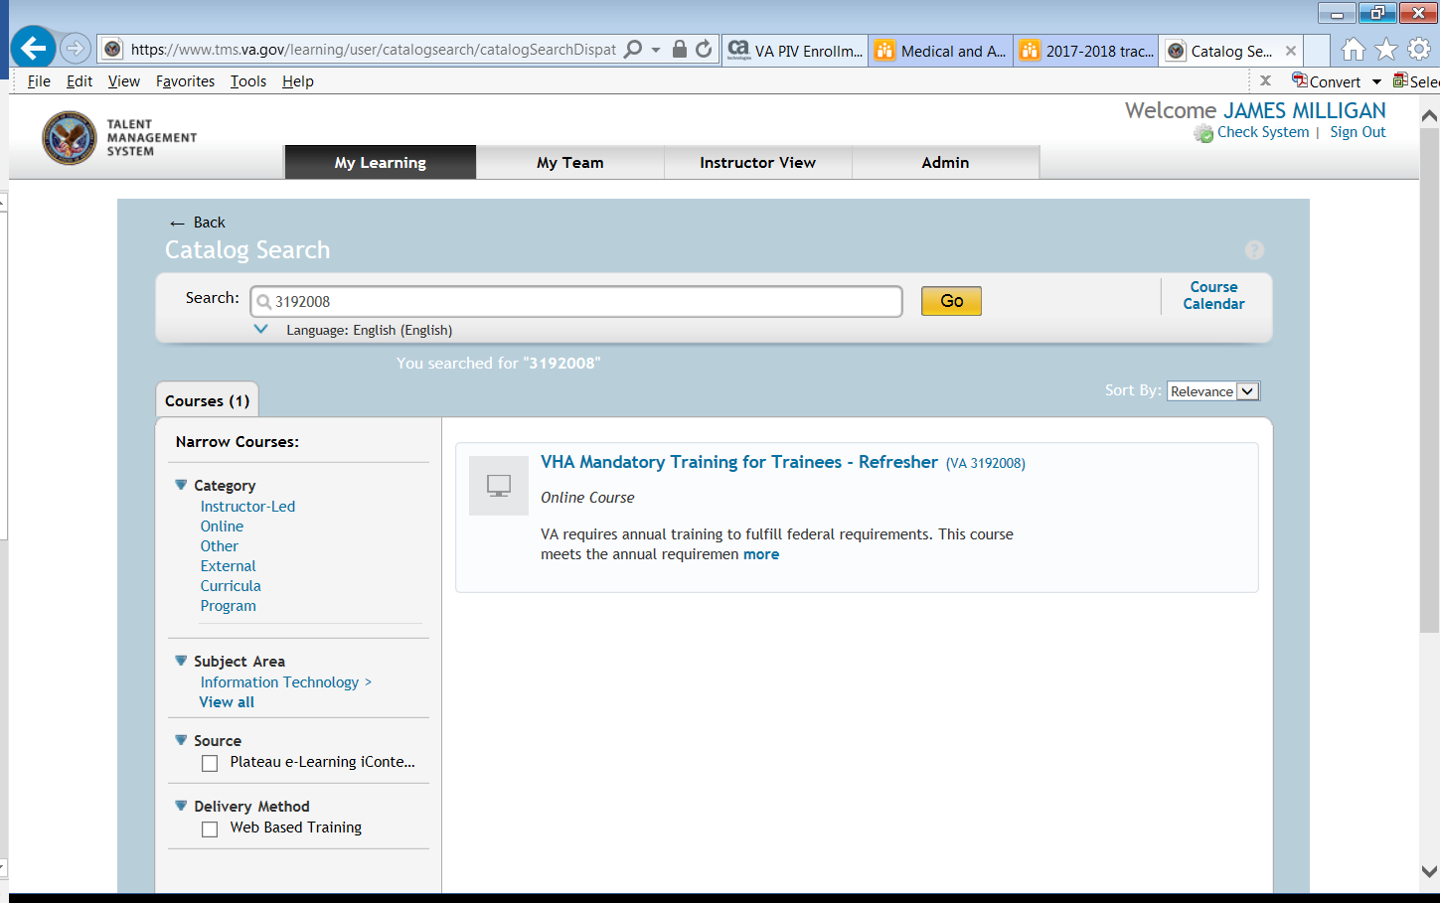
Click Start Course
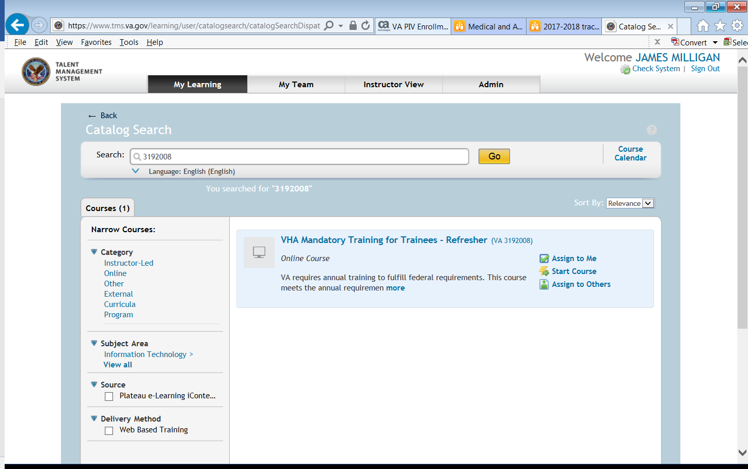
For Password Reset: https://www.tms.va.gov/learning/user/password.jsp

Please email the following if you are having problems with your TMS account.
James | Crystal | Chantell
Service | Service | Service
Ambulatory & Primary Care – BR OPC | Anesthesiology | Dental
All Medicine Specialties | Neurology | Dermatology
Radiology | Pathology & Lab | Emergency Medicine
 | Surgery | Geriatrics
 |  | Med Pediatrics
 |  | Mental Health
 |  | PMR/Pain
James.milligan@va.gov | Crystal.cruz2@va.gov | Chantell.williams@va.gov

