Zoom Breakout Rooms
Overview
Breakout rooms allow users to split Zoom meetings in up to 50 separate sessions. The meeting host can choose to split the participants of the meeting into these separate sessions automatically or manually, and the host can switch between sessions at any time.
Zoom breakout rooms would allow a faculty member or group of faculty members to have breakout room(s) for designated interviewees.
Zoom breakout rooms act as a subset of meeting space outside of a main room. A main room is what a user would join with a Zoom link.
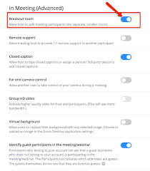
The meeting host (or organizer) will need to activate Breakout Rooms in Advanced Settings prior to creating the meeting they will be used in.
Limitations
Users joined into the Zoom meeting from the Zoom Mobile App or H.323/SIP devices can participate in breakout rooms, but cannot manage them.
Users joined using Chromebook OS or Zoom Rooms are unable to join breakout rooms, but the main room can be used as an alternative session for these users.
Breakout Room Set Up
1. Ensure the meeting host/organizer has the Breakout Room feature enabled in Advanced Settings.
2. Start an instant or scheduled meeting.
3. Click Breakout Rooms from the panel.

4. Select the number of breakout rooms you would like to create, and how the participants should be assigned to those rooms. This is done 1 of 2 ways:
Automatically: Let Zoom split the participants up evenly into each of the rooms.
Manually*: Choose which participants should go into each room.
*This is the option that should be used for interviewing purposes.
5. Click Create Breakout Rooms.
6. The rooms will be created but will not start automatically. The rooms can be managed prior to starting or opening them.

Options for Breakout Rooms
The following are options that can be selected for use with a breakout room. Setting these up with consideration to each detail prior to the breakout rooms being in use is critical. Once the breakout rooms start, you are unable to change these settings.
Breakout rooms close automatically after X minutes: If this option is checked, the breakout room will automatically end after the configured time. All participants and all rooms are able to see a countdown timer. It will automatically remove users from the breakout rooms after the set time. You will not have the option to manually close the rooms if this is selected. To prevent this, select ‘Countdown after closing breakout rooms’
Notify me when time is up: If this option is checked, the host will be notified when the breakout room time is up.
Countdown after closing breakout rooms: If this option is checked, the participants will be given a countdown of how much time they have left before being returned to the main room. This allows additional time after the rooms are closed to exit back into the main screen. This would allow you to set the duration of your interviews, but still allow a 1-2 minute wrap up instead of automatically closing and potentially interrupting conversation. There would be a warning. All breakout rooms will be able to see a countdown timer for this too. This can be used if you do not use the automatically close function. You are able to observe the time and click on ‘Close Breakout Rooms’ and it will start the timer before everyone is sent back to the main meeting.
Allow participants to return to the main session at any time: If this option is checked, the participants can move back to the main session from their meeting controls. If this is disabled, they need to wait for the host to end the breakout rooms.
Move all participants to breakout rooms automatically: Checking this option will move all participants into the breakout rooms automatically. If this option is unchecked, the participants will need to click Join to be added to the breakout room.

Pre-Assigning Participants to Breakout Rooms
Assigning Internal Participants
- Login to Zoom on the web portal
- Click on the meeting you need to assign breakout rooms
  - If breakout room pre-assign is not already active, you will have to click on ‘Edit’ to enable this feature.
- Select ‘+ Create Rooms’ and here you can create the rooms and add people within your institution by simply typing in their name as shown below.
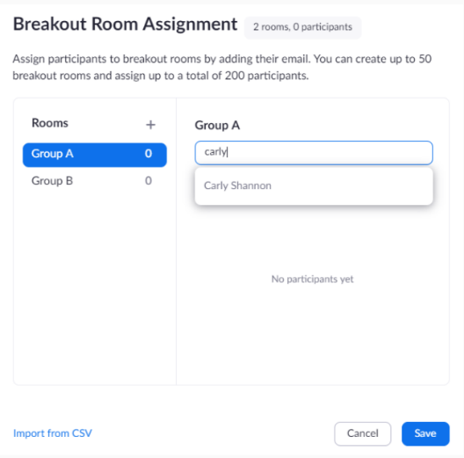
Assigning External Participants
- Login to Zoom on the web portal
- Click on the meeting that you need to assign breakout rooms
  - If breakout room pre-assign is not already active, you will have to click on ‘Edit’ to enable this feature.

- Select ‘Import from CSV’
  - To create a CSV file, open a new Excel spreadsheet or download template from the Zoom support website and scroll down to where it says ‘download a sample CSV file’.
  - Format the spreadsheet as shown below. You will need to list the Room Name or Room Number and each participant on a separate line.
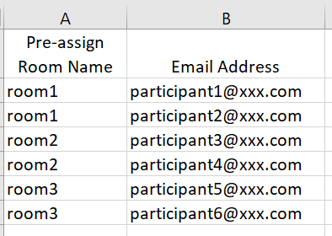
  - Once you have created this file, you will need to click on the drop down for ‘Save as type:’ and change it to CSV.
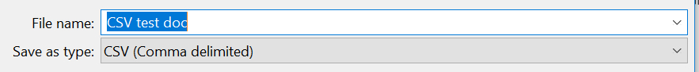
  - Once the document is saved, you can upload it in the web portal on Zoom.
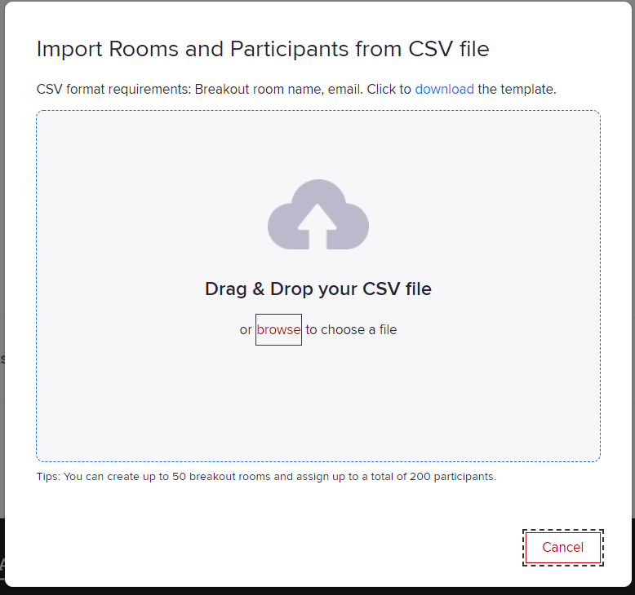
Manually Adding Participants to Breakout Rooms without Pre-Assigning
- Click on the ‘Breakout Rooms’ icon at the bottom of the panel. This can be done before anyone enters the meeting but it will show 0 participants. Also, no participants will be able to be placed in the breakout rooms until other participants are logged into the meeting. You can only select the number of rooms you will need and create them.
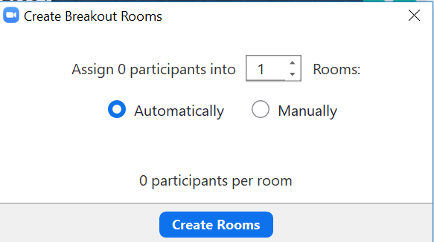
If you select automatically, it will randomly assign participants as they sign into a room.
If you select manually, you can place participants in the rooms you want.

- Once you have created the number of rooms you need, you will see the main platform to control everything associated with the breakout rooms.
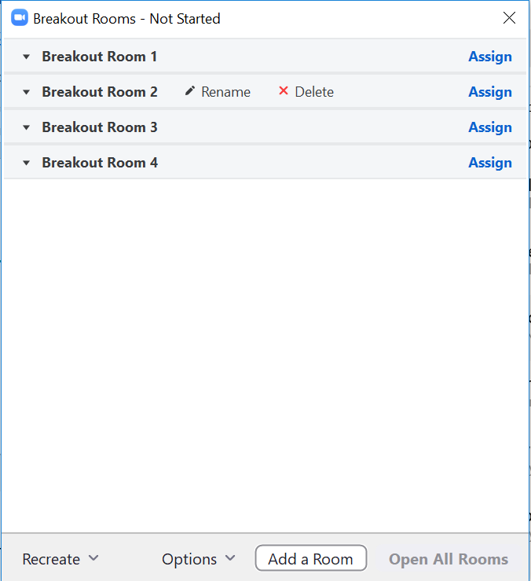

- You are able to see in the example above that you can rename, delete or add rooms even after they have been created as long as they are not active or in session at the time the changes need to be made.
- When you ‘Assign’ to place participants into rooms, it will list all current participants names with a check box so they can be assigned.
  - As the individual participants are assigned to rooms, their name will disappear from the overall list.
  - If anyone joins the meeting after the host assigns participants to rooms, their name will show up on the list.
    - If you click ‘Assign’ and no names populate, you know that you have assigned all participants to a room. If there are names, these are the people that would remain in the main meeting. This can also serve as a waiting room.
    - For applicant interviews, current residents/fellows can wait in the main room with those applicants that have not been placed in a breakout room to engage with them in an informal setting.
  - Remember to select all options (time limit, time countdowns, etc.) prior to opening all of the rooms.
Active Breakout Room Sessions
- If a participant has joined the breakout room, they will have a green dot next to their name.
- If a participant has not joined, their name will be gray and say (Not joined)
- The host can join any of the breakout rooms at any time
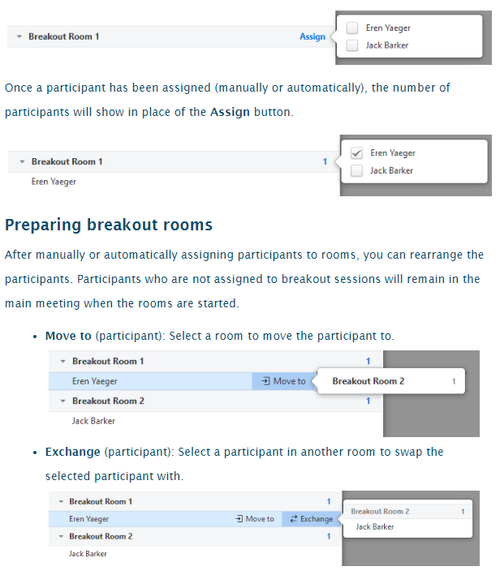
- The host can send a ‘Broadcast Message’ to everyone and all groups at the same time (i.e. Take a few minutes to introduce yourselves or Please note all rooms will close at 3PM, applicants please return to main meeting room at that time.)
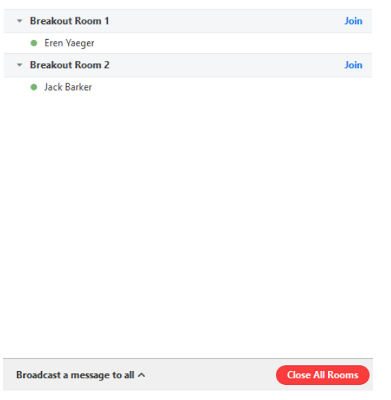

Considerations for Interviews:
Breakout rooms do not necessarily need to be closed. A broadcast message can be sent to all participants at once indicating that time is almost up and asking all applicants to return to the main meeting room. Doing this would allow faculty to stay in the breakout rooms (they would be moved out of it if the breakout room closed automatically). Applicants could then move from the main room into the next breakout room with the next faculty member on their schedule.
Once all breakout rooms are closed, the rooms and participants within them stay the same but everything will show as inactive. The host would need to select ‘Exchange’ or ‘Move to’ next to each person’s name – this would allow the host to only move applicants or faculty into new rooms. Then select ‘Open Breakout Rooms’ and the new sessions start.
If the host of the meeting needs to be changed for any reason, the previous rooms and participants will automatically populate for the new host.
Waiting Rooms:
This feature allows the host to conduct small group interviews (for example, 3 faculty and 1 applicant) without risking anyone else entering the meeting and still only creating one link.
As the host, you would get a notification that someone was trying to join the meeting and the host will have to ‘Admit’ them into the meeting.
This feature needs to be enabled by logging on to the web portal and click on the meeting that the waiting room is desired. Click the ‘Edit’ option within the meeting details.
Scroll down to Meeting Options and select to enable the waiting room.
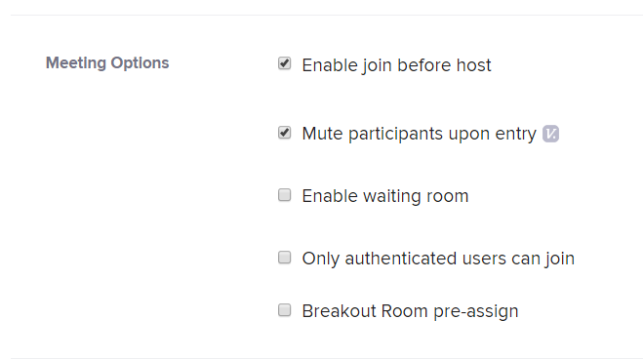
For more detailed options review the Zoom support information on waiting rooms.

