To ensure you are registering correctly please see the screen shots below I included to help you.

**Step 1:  OPEN THE TMS 2.0 Link:** <https://www.tms.va.gov/SecureAuth35/>  **AND CLICK ON “CREATE NEW NON-EMPLOYEE USER”**

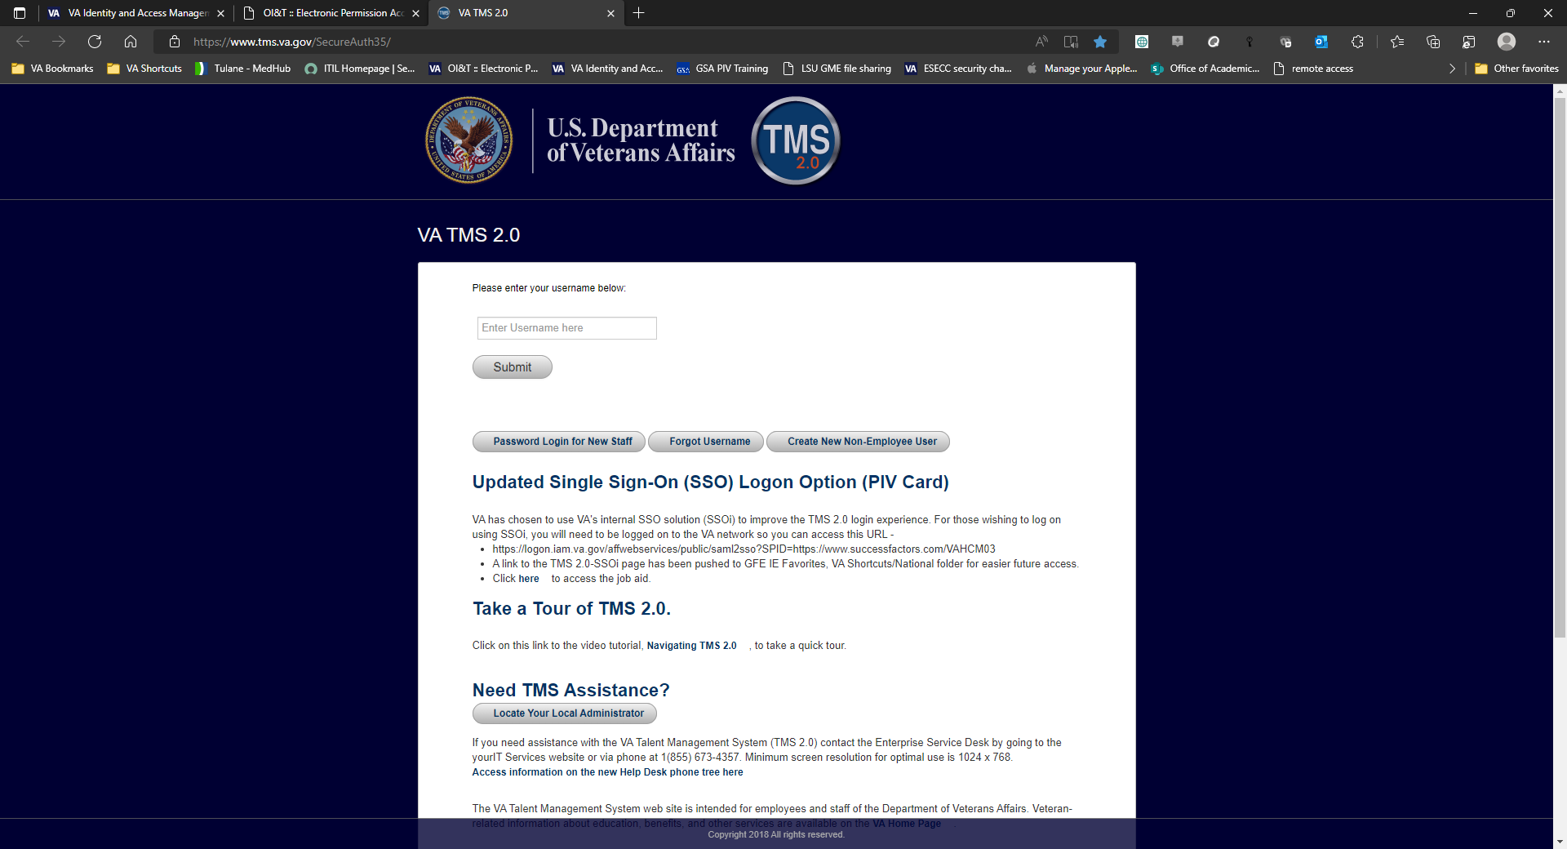

**STEP 2:  SELECT THE OPTION THAT STATES “VETERANS HEALTH ADMINISTRATION” AND THEN CLICK THE NEXT BUTTON BELO**

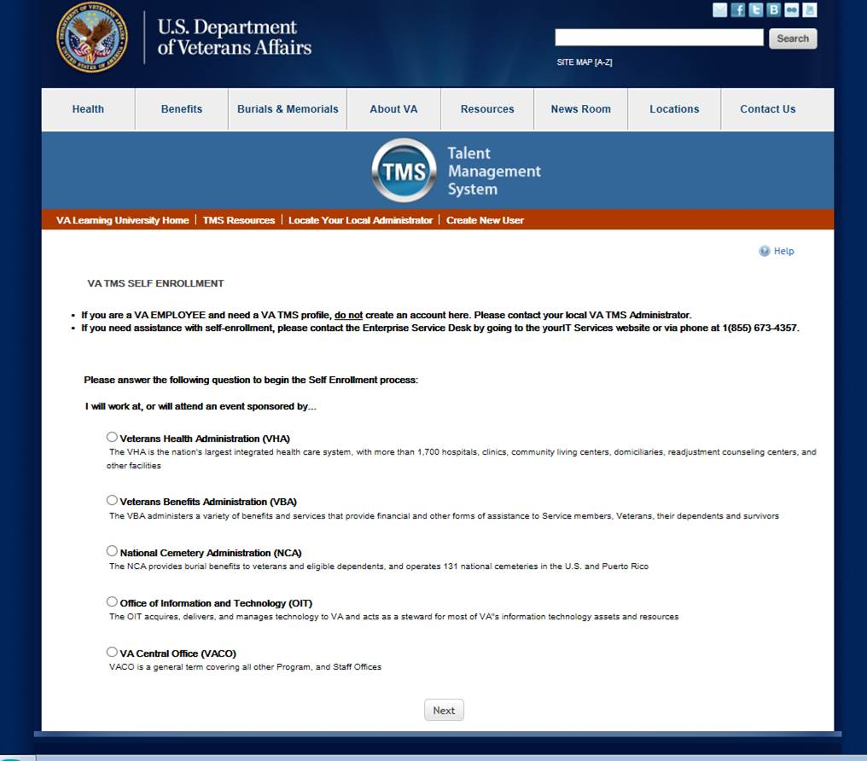

**STEP 3: SELECT THE CORRECT OPTION AND THEN CLICK THE NEXT BUTTON BELOW**

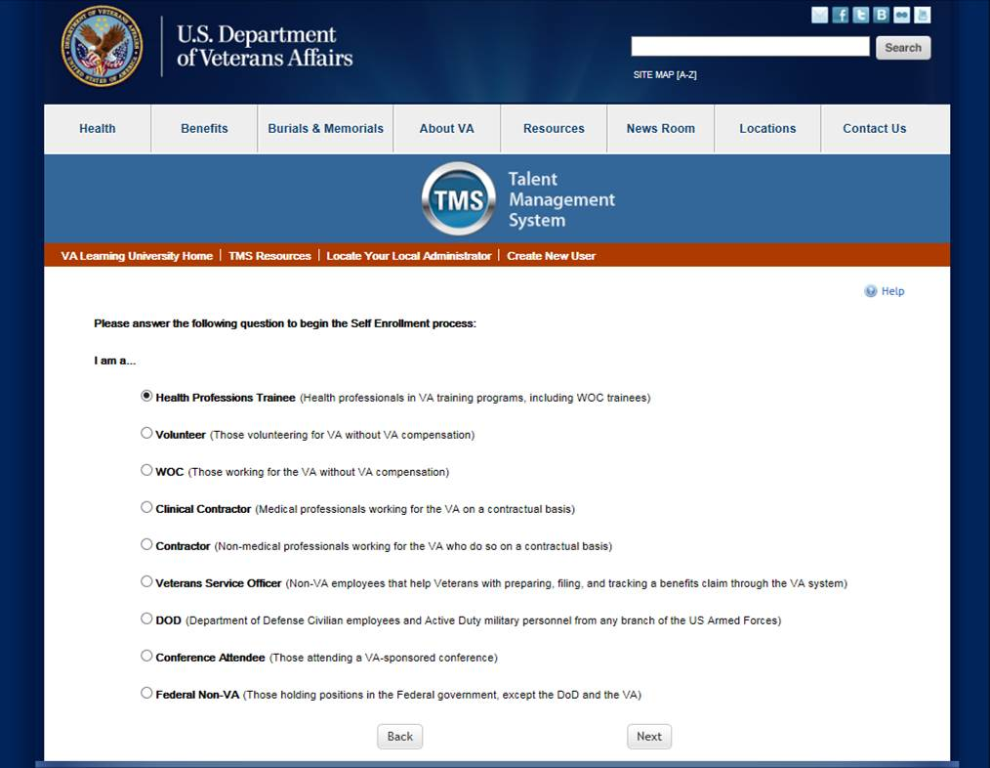

**STEP 4: COMPLETE ALL THE REQUIRED FIELDS IN THE “MY ACCOUNT INFORMATION” PORTION.  (IT IS IMPORTANT THAT YOU ENTER IN YOUR PRIMARY EMAIL AND A GOOD PHONE NUMBER)**

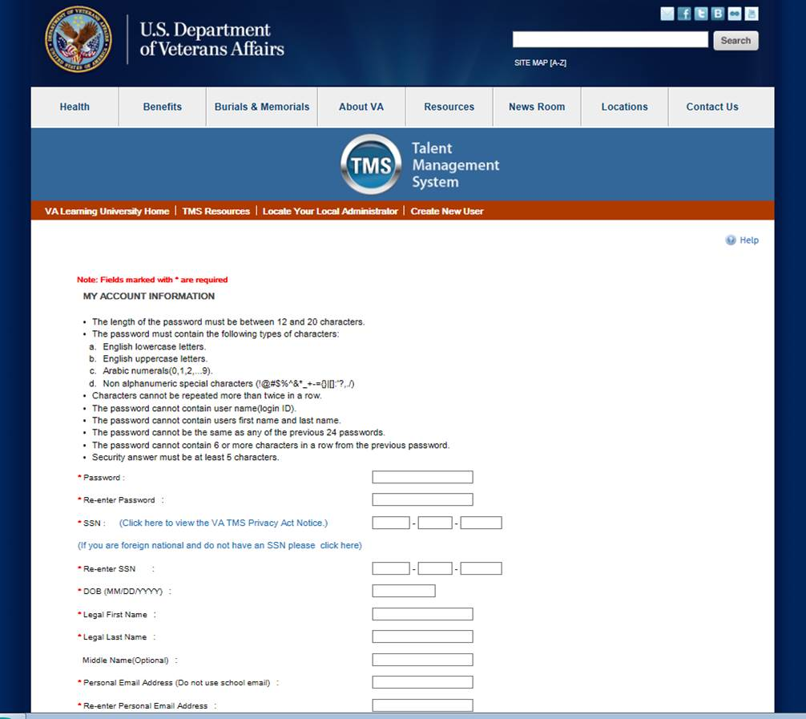

**COMPLETE THE REQUIRED FIELDS IN THE “MY JOB INFORMATION”**

**MY JOB INFORMATION**

VA Location: NOL (Southeast Louisiana Health Care System)

Trainee Type:

Specialty/Discipline:

VA point of contact first name: Crystal

VA point of contact Last name: Cruz

VA point of contact Email address: Crystal.Cruz**2**@va.gov

Point of contact phone number: 504-202-6443

School/University: enter in your school

School start date: enter in today’s date

Estimated school completion date: This should be your program end/graduation date

**Click “submit” when done**

**NOTE: YOU WILL RECEIVE A CONGRATULATIONS PAGE IF YOU HAVE SUCCESSFULLY REGISTERED WITH YOUR USERNAME AND INSTRUCTIONS TO WAIT 20 MINS FOR YOUR ACCOUNT TO BE ACCESSIBLE BEFORE YOU CAN LOGIN.**

**AFTER REGISTERING**

**The primary manual login method for TMS 2.0 is the username/passcode process. To log in using this process;**

1. **Navigate to** <https://www.tms.va.gov/SecureAuth35/> **, enter your username. Then, select Submit.**

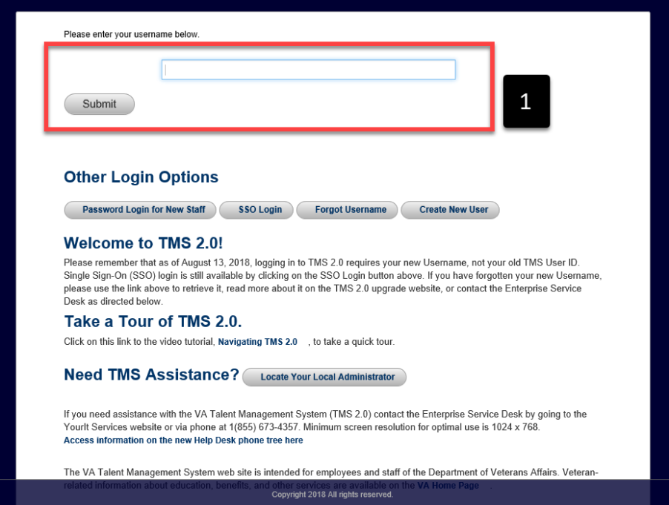

1. **Choose the delivery method to receive your Passcode and select Submit. *(I RECOMMEND USING YOU PHONE NUMBER FOR INSTANT DELIVERY)***

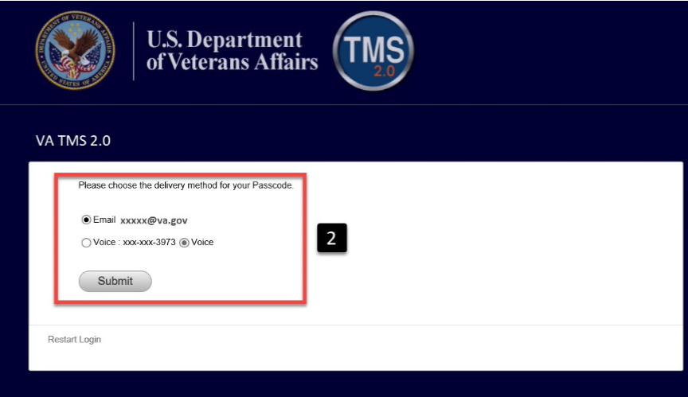

1. **Enter the Passcode you received via the selected delivery method in step 2 and select Submit**

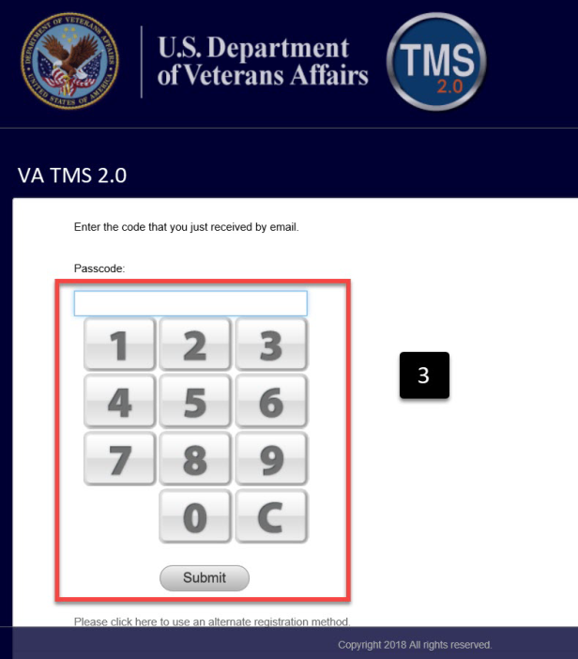

1. **Once logged in, the TMS 2.0 landing page displays.**

