Panel Discussion: Helpful tips and tricks for this Recruitment/Interview Season

Catering/restaurant recommendations
    - La Madeline, Panera Bread, Jason’s Deli, Taco Bell

    - Toulouse Gourmet: https://www.toulousegourmet.com/
- 3811 Toulouse St, New Orleans, LA 70119
- (504) 488-4466

    - Simple Greek: thesimplegreek.com
- 419 Carondelet St, New Orleans, LA 70130
- (504) 302-7482

    - Parkway Bakery & Tavern: https://parkwaypoorboys.com/
- 538 Hagan Ave, New Orleans, LA 70119
- (504) 482-3047
**Will cut and prepackage po’boys

    - Roly Poly: https://rolypoly.com/
- Hancock Whitney Center, 701 Poydras Street, on 1st Floor, New Orleans, LA 70139
- (504) 561-9800

    - Caluda’s Cottage Catering: https://www.cottagecatering.com/
- 1536 River Oaks Rd. W, Harahan, LA 70123
- 504-343-5706

    - Gracious Bakery: https://www.graciousbakery.com/
**fee for individual boxed lunches

    - Da Wabbitt: http://www.cafe615.com/
- 615 Kepler St, Gretna, LA 70053
- (504) 365-1225

    - The Kolache Kitchen (breakfast/lunch): https://thekolachekitchen.com/
- CBD & Freret St. locations

    - Espresso Express:
- Hancock Whitney Bank, 701 Poydras St # 116, New Orleans, LA 70139
- (504) 524-5115

Take-aways post interview:
- Nothing Bundt Cake

ii. Recipe cards with New Orleans food/drinks
- Red beans and rice, Pimms cup, etc.

iii. NOLA Visitors Guide (free)

iv. Baskets with:
- Tony’s Chachere’s, recipes, coasters/koozies (LSU), Zapps chips, etc.

In-Person Welcome Party
- Bourbon House
- 144 Bourbon St, New Orleans, LA 70130
- (504) 522-0111

- Mother’s: https://mothersrestaurant.net/
- 401 Poydras St, New Orleans, LA 70130
- (504) 523-9656

- Hop On Hop Off Bus Tour: https://www.citysightseeingneworleans.com/

- Manning’s: https://www.caesars.com/harrahs-new-orleans/restaurants/mannings-sports-bar-grill?utm_campaign=GMB&utm_source=google&utm_medium=local&utm_term=Mannings&utm_content=Restaurant&y_source=1_NDM2NjkxNS03MTUtbG9jYXRpb24ud2Vic2l0ZQ%253D%253D
- 519 Fulton St, New Orleans, LA 70130
- (504) 593-8118
**2.5-3k minimum for courtyard and upstairs room

- Lucy’s Retired Surf Club: https://lucyssurf.com/
- 701 Tchoupitoulas St, New Orleans, LA 70130
- (504) 523-8995
**around 3k

- Ralph’s on the Park: https://www.ralphsonthepark.com/
- 900 City Park Ave, New Orleans, LA 70119
- (504) 488-1000
**on the pricier side

Tips for Reviewing Applications
- Look at:
- Hobbies, personal statements, letters of recommendation
- Louisiana ties
- Pictures- for recognition

- Record/Note:
- Email responsiveness
- Professionalism
- Preferred name

Building Relationships during Recruitment/Interview Season:
- Team meeting
- Discuss and plan who will be responsible for certain talking points
- Ex: New Orleans Culture, didactics/journal club, clinical schedules, private practice/career, etc.
- No-Go List- EEO Guidelines for Interviewing Applicants.pdf
  - ***List from Jeanne Zar in Surgery
- Review with entire team (including Residents who are interviewing)

- Building Relationships with Interviewees
- Use positive language:
- Ex: “We are so excited to meet you!”
- “Thank you for the opportunity to get to know you better!”

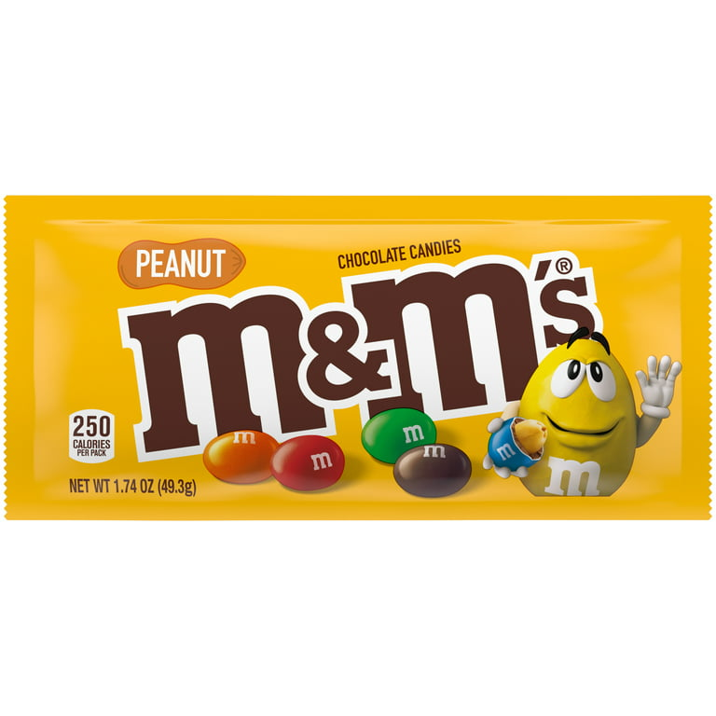
- Recruit with the 4th year visiting students.

