HOUSE OFFICER GUIDE TO ONBOARDING
Welcome to LSUHSC-NO. We are so glad you are here and that your residency/fellowship will beginning in just a few short months. Please help me out and complete the following as soon as you can. All documents, must be printed and wet signed and then mailed to me.
Insert Program Coordinator Name
Program Address

Unfortunately, LSU HSC HR cannot accept electronic signatures for most documents. Complete the forms ASAP so that if there is an error, we have time to fix it! Everything must be turned into me by MAY 1st. Failure to complete all forms by the deadline could impact your July 1st start date.
Basic Info. DO THIS FIRST!
Information needed to set you up in New Innovations and with GME. Please feel free to call me with sensitive information if you do not want to send it via email (**SSN).

Gather documents. You will need lots of official documents during the onboarding process. If you cannot locate these items you will need to apply for them and have replacements made. This can take time so I ask that you look for these items and make sure you have them. Examples include birth certificate, valid driver’s license and social security card. For I-9 you can use pass ports, resident cards, authorization documents, etc. in replacement, but you will still need the SSC for LSU. COPIES ARE NOT ACCEPTABLE, YOU MUST SUBMIT ORIGINALS (they will be returned).
Visit https://www.uscis.gov/i-9-central/form-i-9-acceptable-documents for which documents you will need for I-9.

Obtain National Provider Identifier.
Part 1: Create a login for the Identity & Access Management System (I&A).
- Go to https://nppes.cms.hhs.gov
- Click “Accept” at the Terms and Conditions screen.
- Click on “CREATE or MANAGE AN ACCOUNT”. Click “ok”.
- Click “Accept” at the Terms and Conditions screen.
- Click “Create Account Now” on the right hand side of the screen.
- Enter all necessary information to create account.
* Record your login information and keep in a safe place. You will need it to change your NPI registration in the future.
Part 2: Apply for NPI
- Go back to NPPES (https://nppes.cms.hhs.gov) and log in with username and password created above.
- Click the “Apply for an NPI for myself” button. Use the info below to apply.
Important information for NPI application
Is this provider a Sole proprietor - NO
Business Address – must be an address where you can currently receive mail. It is
recommended to use your current local mailing address (it can be changed later).
Phone Number – Must be a phone number where you can currently be reached.
Note: This number is public information, and can be looked up by anyone. Once you begin your residency, it is recommended to change this number to your program phone number. (504)568-7912
Business Practice Location Address – Click the “Same as business Mailing Address” button.
Note: Once you begin your residency, this should be updated to your program’s
address. 2021 Perdido St. Rm. 6240. New Orleans, LA. 70112
Other Identification Numbers – You do not currently have any other identifiers to enter.
Endpoints – You do not have any endpoints to enter.
Taxonomy – Type “student” into the search box, then choose “390200000X – STUDENT IN AN
ORGANIZED HEALTH CARE EDUCATION/TRAINING PROGRAM” from the drop down
menu.
License – Do not add any license information.
Contact Person – Click the “Same as Provider” button.
*After completing the application, in most cases, the NPI is emailed to the email address given within a few minutes. *Please send me your NPI number.

_____ Email with ID number and PIN number sent out.

Complete New Hire Packet and Site Packet(s).
Open the email you received from me on ____.
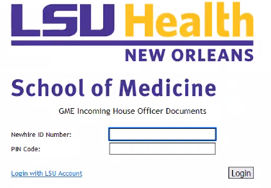
Click on the link, it should bring you to a page that looks like this.

If you have an LSU account already, click “Login with LSU Account” otherwise, use the new hire ID and PIN code.
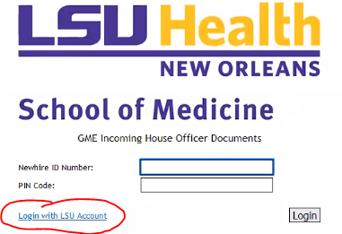

Once logged in, this is what you should see.
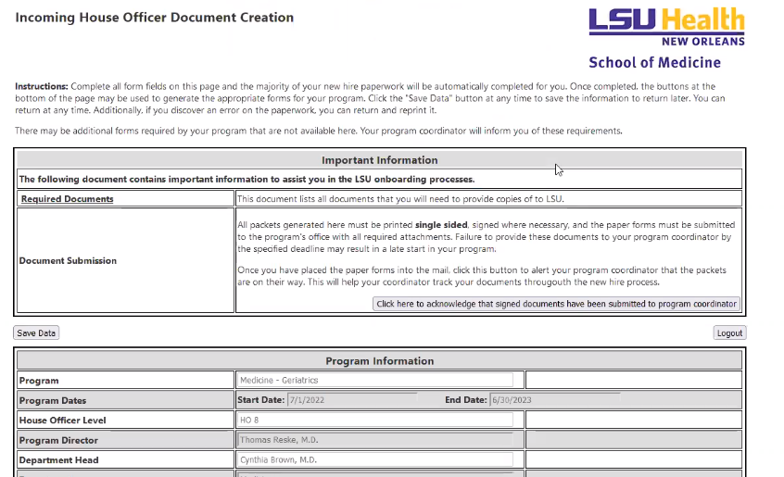
- Read the instructions at the top of the page.
- Fill out all data on the form. Some basic data has been pre-filled. Make any corrections as necessary.
- Data can be saved by using the “Save Data” button at the top of the page. Data is automatically saved when the forms are generated.
- For security reasons, SSNs are NOT saved in the system. If you return to compete the form later, you will need to re-enter SSN.
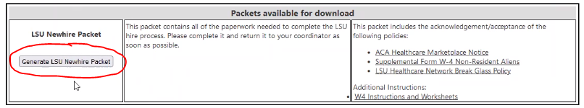
Once complete, next, at the bottom click “Generate LSU Newhire Packet”. On the right column, below, are policies you are agreeing to and may have further information/instructions if needed.

The next page should look like this.
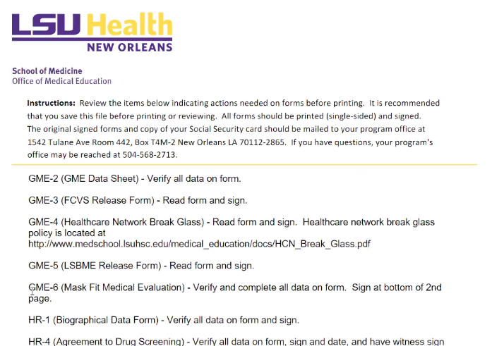
The first sheet is the instructions for the packet. It explains what to do on each sheet. Fill out electronically as much as you can and then print the entire document. Sign each signature/initial spot. NO ELECTRONIC SIGNATURES.
Next, go back to the document creation page (the first page you came to when you logged in). At the bottom of the page, a number of facility appointment packets will be available for download. For each packet, click the "Generate" button to produce a PDF of the packet's materials, automatically populated with the information entered above. Complete each packet, print, sign and put with the new hire packet that you previously completed.
* Pay attention to any informational documents listed on the right column for each packet. These are policies that you are agreeing to in the packets, and for some packets, there are also instructions for online training modules.
* If any forms need to be updated, you can re-generate the forms at any time with updated information (update the information on the initial document creation page and it should change on the form).
Finally, all forms will need to be printed, signed, and submitted to me. Electronic signatures or scanned copies of these documents are not acceptable. Please advise me when you send them so I can be on the lookout for them! I will let you know when I receive them.

Obtain Louisiana Medical License / Training Permit.
Complete LSBME permit and submit to LSBME with required fees.
Go to the Louisiana State Board of Medical Examiners http://www.lsbme.la.gov/licensure/physicians
Under “Training Programs”, click either “US Medical Graduates” or “International Medical Graduates”.
At the top of the following page, Click “LaMED DashBoard” at the top.
Scroll down and either log in or register.
Follow the prompts form there and submit fees. (Fees should be around $50, if asked to pay more than that, you are completing the wrong application. Foreign medical grads will be ~$200)
Complete fingerprinting/background check.
Complete required forms.
Notify me that you completed this step when complete.

I’ve had lots of questions regarding the certificate of Dean/Registrar so see below for instructions.
Certificate of Dean/Registrar – LSU Med School Graduates: If graduating in May, should have received a copy of the form in an email, print it out, and in the presence of a notary, complete, sign and have the form notarized and bring to LSU Student Affairs. The form in the email already has the Medical School name and graduation date entered. Once turned into LSU Student Affairs, they will mail it to LSBME.
LSU Med School Graduates who graduated prior to May, print out a blank LSBME Certificate of Dean Form from the LSBME website. In the presence of a notary, fill out the top (Name and SSN), attach a photo and sign the form. Have the notary notarize the form. Then bring the form to LSU Student Affairs for them to complete section 2. LSU Student Affairs will then mail it to LSBME.
NON-LSU Med School Graduates – Follow the steps of an LSU Med School Graduate who graduated prior to May 2023, except you will bring it to your med school’s student affairs office (not LSU’s) and your med school will mail to LSBME.
*The Oath of Affirmation, Third Party Authorization and the Certificate of Dean/Registrar must all be notarized. You can bring all three of these at the same time.
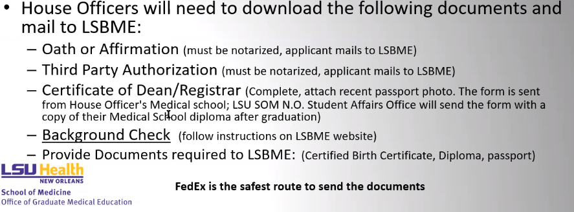

Enroll in Medicare as an “Ordering and Referring Provider”.
Must have LSBME permit to apply.
All residents are required to be enrolled in the Medicare PECOS system as prescribers in order to write drug and durable home-health equipment prescriptions for Medicare patients. Registration cannot be completed until the resident has a valid medical license or permit. Any resident who is not registered cannot write prescriptions for home-health equipment. For further information visit https://www.cms.gov/Medicare/Provider-Enrollment-and-Certification/Preclusion-List.
To enroll in PECOS
- Go to Medicare PECOS system at https://pecos.cms.hhs.gov/pecos/login.do
- Log in with the username and password created when applying for NPI.
- Apply as an Ordering and Referring Physician (Form CMS-8550).
- Notify me this has been completed.
* For assistance with registration contact Novitas Solutions
https://www.novitas-solutions.com/webcenter/portal/NovitasSolutions
(855)252-8782, option 4.

Apply for your CDS License.
It is recommended that you do not apply until after your LSBME permit has been issued.
When completing the application, you need to request the following CDS Schedules: II, III, IV, and V.
Go to https://www.pharmacy.la.gov/page/cds-forms-applications
Apply through #101.

Employment Eligibility Verification AKA “I9”.
All Incoming House Officers must complete a U.S. Citizenship and Immigration Services Employment
Eligibility Verification form (USCIS I-9) using HireRight*. HireRight will send an email with a link and instructions on or after May 15 to complete the I-9 application. If you do not receive the email from HireRight, contact the GME office at gmeonboarding@lsuhsc.edu.
**US Citizens and Permanent Residents will need to fill out Section 1 of the I-9 form no later than June 1.

I9 Document Review:
Between now and June ___, you must present in person the i9 original documents to Kat. If out of state beginning of residency, you must bring these to the in-person LSU orientation on June 24th or 25th.
Bring your social security card and your driver’s license to my office OR a non-expired passport may be used.

Contract:
I will send you an electronic contract to sign. After you sign it, it goes to the Program Director -> Department Head _> the Dean. With lots of new contracts passing through the Dean’s office, they can get swamped, therefore do not hold on to your contract, sign ASAP.

TB Test:
Annual TB test and supporting documents (complete now if you can). There will be a “TB fair” on campus (date and time TBD), but you do not have to have it completed there. (Submit paperwork to Kat, she will submit electronically to GME.) Due May 15th!

VA On-Boarding: Due April __
- Use this QR code or link to access GME’s VA onboarding instructions:
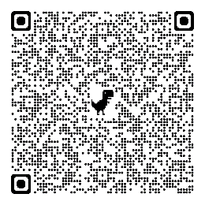

https://lsugme.atlassian.net/wiki/spaces/AY/pages/15859806/2023-2024+VA+On-Boarding+Process+-+Southeast+Louisiana+Veterans+Health+Care+System+SLVHCS?preview=/15859806/2965471269/New%20resident%20application%20%26%20checklist.pdf

- Print your TMS certificate.
TMS certificate = the VA training unit and HIPPA, privacy, etc. Only one a year must be done.
VA TMS certificate looks like this:
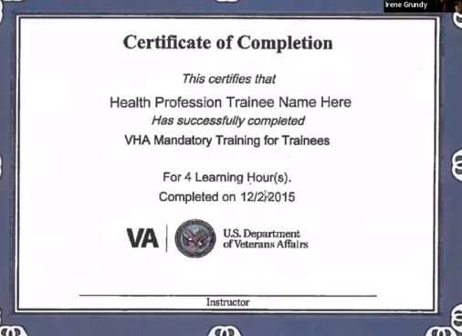

- Males – Search your name on the Selective Service Registration and print the confirmation page.
https://www.sss.gov/verify/ (Link is also under #3 on the above QR code/link.)

- Fingerprints –

LSU Pre-Orientation Online Videos – Not available to watch until May 15st (all must be completed by June 15th)
Go to https://www.medschool.lsuhsc.edu/medical_education/graduate/VirtualOrientation to access the LSU virtual orientation videos. You will need to use your LSU login to access them. Videos must be watched by June 15th, 2023. These do not replace the in-person orientation, as you must attend the in-person orientation on either June 27th or 28th, as well.

LSU appointment packet/new hire electronic forms. This will be sent out to your new LSU email address on May 15th. Note: This is completed every year. Due June 15th.
- FCVS Release Form
- LSBME Release Form
- Copy of Driver’s License and Out-of-State Official Driving Record (if applicable).
- House Officer Moonlighting Form
- House Officer Manual Confirmation
- COVID Release Form
- Health Requirement Worksheet and supporting documents – vaccinations/physical.
LSU ID photo: Resource Building Benefits Office 425 S. Roman St. 6th floor. You will receive your badge at the LSU orientation. ID photos not taken in advance will be taken at the orientation.
LSU emails: If you do not have an LSU email address, you will receive an email at your non-LSU email on May 15th, with steps on how to setup for LSU email address. You will need this to do the LSU pre-orientation videos (see above), your appointment packet (see above), and many other items. Set this up as soon as you get the email and from that point forward you will use only the LSU email address to communicate with the department, GME, etc.
Drug Screening: After April 1st but before April 30th. Contact me to set up.
EPIC Training: Epic training will be virtual. Modules will be given out prior to orientation (beginning of June), and must be completed by June 29th, 2023.
LSU GME Orientation:
Monday, June 24, 2024 and Tuesday, June 25, 2024, the LSUHSC Orientation will be held from 9:00a.m. to 4:00p.m. at the GME Offices (2020 Gravier Street, 6th floor, New Orleans, LA 70112). Each resident/fellow will be scheduled for a timeslot on one of the above listed dates. Parking is available in the Roman Street garage for those that have already registered for LSU parking; anyone that has not registered for parking may park in Student Lot #3. A map of the downtown campus can be found at http://www.lsuhsc.edu/maps/downtown.aspx. For other information concerning orientation, please check the website at https://lsugme.atlassian.net/wiki/spaces/NEWHIRES/pages/14811473/GME+Orientation.
If you have any questions regarding the LSUHSC orientation, please feel free to contact the Graduate Medical Education Office at gmeonboarding@lsuhsc.edu or 504-568-4006.

UMC/LCMC Orientation: June 26th, 2024. Pick-up day. Online modules required. Virtual Orientation sessions TBD. Parking is available in the Roman St. garage for those who have already registered for LSU parking. Anyone who has not yet registered may park in student lot #3.
There will also be a live Zoom Orientation session scheduled that house officers are invited to attend, dates and time are TBD.
UMC Parking Registration:
LSU GME has put together a check list based on the above information. You may look at it as well, as they update it frequently.
https://lsugme.atlassian.net/wiki/spaces/FORMDOCS/pages/903118888/Incoming+House+Officer+Checklist?preview=/903118888/2973761537/Required%20Actions%20for%20Incoming%20House%20Officers%202023.docx

IF YOU HAVE ANY QUESTION, PLEASE REACH OUT TO ME! I AM HERE FOR YOU!

